**Reliance Animal Clinic**

**Data Management Project**



**Team 7**:

Rushi Dalal

Raghavan Krishnan Veera

Yenglui Chia

Priyank Patel

**MIS 6326.003**

Professor Kutsal Dogan

**Table of Contents**

Problem Description ……………………………………………………………………………2

Company Background ………………………………………………………………….3

Current Issues …………………………………………………………………………..4

Scope of Database

Appointment Table ……………………………………………………………………..4

Billing Table……...……………………………………………………………………..4

Insurance Company Table ………………………….…………………………………..5

Employee Table…………..……………………………………………………………..5

Insurance Table……………...…………………………………………………………..5

Owner Table…………………………………………...………………………………..6

Payment Table…………………………………………………………………………..6

Pet Table…………………………….…………………………………………………..7

Prescription Table…………………...………………………………………...………...7

Visit Table ……………………….……………………………………………………..8

Visit Detail Table …………………….………………………………………………...8

Entity Relationship Diagram with Definitions ………………………………..………………..9

Relational Database Schema………………………………………………..…………………..10

Menu and Data Input Screens…………………………………………………………………..14

Sample Reports ……………………………………………………………….………………..20

Individual Contribution…………………………………………………..……………………..23

**Company Background**

Reliance Animal Clinicis a local veterinary clinic company founded in 2010 in Allen, TX. It started out as a small facility, and gradually grew upon good reviews from veterinarians in the area. Reliance Animal Clinic currently has around 20 employees. This consists of 15 regular staff and 5 veterinarians. The clinic contains state of the art medical, surgical and lab equipment. This clinic offers a variety of services serving to all clientele commonly found in households such as dogs, cats, rabbits, hamsters, and birds. Here is a list of services currently offered:

* Annual Examination
* Orthopedics
* Diagnostic and Lab Procedure
* Emergency Care
* Pet surgery services

Furthermore, Allen, TX has experienced dramatic population growth over the last twenty years. It is the 2nd fastest growing city in the DFW area. More people are buying pets and due to the city booming, there is a greater need of veterinary services in the area. To meet the needs of this growing demand, we need to make changes to our current business structure.

**Business Process:**

Here is the procedure by which the veterinary clinic operates and provides service to patients:

* The owner of the dog will call the veterinary to set up appointment for his/her pet. The owner will provide his/her name along the name of the patient (pet). Based on the provided information the clinic will either record or pull patient history and an appointment will be set up.
* If it is a new customer certain information will be requested such as the type of pet and services required.
* When the patient visits the store, the information of the patient will be pulled up via the appointment previously scheduled.
* At the end of the visit the services performed will be recorded and charged to the owner through one of the billing options.
* Medication may also be prescribed to the patient, in which case it will be added to billing and patient information.
* The vet clinic will also offer boarding services with specific rates based on the type of animals and the duration of stay.

**Current Issues and Solution:**

Currently the organization is using paperwork/ledger system to keep track of the information about the appointments, owner, pet and the services offered for each of the customers during their visit. This type of system to track the information would be useful when the number of customers is small, but as the customer base grows it will be very difficult to track. Also, it would not be quickly accessible and we can lose information about the customer or the services done. In other words, we cannot have a good control over the data. To solve this purpose, we can use database which has the following advantages:

* Keeping better tracking of past and present records
* Ability to update client information
* Quick accessibility is one of the main issues that is prevailing
* We can avoid redundancy in the customer information
* Increased security

**Scope of Database**

Currently Reliance Animal Clinic uses unorganized paperwork/ledger system that causes a challenge for employees to save and find customer information. With the implementation of this new database, it will be easier to collect information and find them whenever the customer returns to the clinic. There are a total of 15 tables with their description listed below.

**Appointment Table**

The table consists of all the appointments obtained by the receptionist. Each appointment is identified by a unique number labeled as ID. Information contained includes Appointment Date and Time, Employee ID and Pet ID.

|  |  |  |  |
| --- | --- | --- | --- |
| **Appointment** | **Description** | **Data type** | **Remarks** |
| Appointment_ID | Identify Appointment | INTEGER | PRIMARY KEY |
| Emp_No | Identify Employee | INTEGER | Required; FK references Employee (Emp_No) |
| Pet_ID | Identify Pet | INTEGER | Required; FK references Pet (Pet_ID) |
| Appointment_Date | Date the appointment is set to | DATE | REQUIRED |
| Appointment_Time | Time set for appt. | TIMESTAMP | REQUIRED |

**Billing Table**

The table consists of all billing statements giving to the customers at each visit. Each Billing statement is identified by a unique number labeled as ID. Information contained includes Billing Date and Amount and Visit ID.

|  |  |  |  |
| --- | --- | --- | --- |
| **Billing** | **Description** | **Data Type** | **Remarks** |
| Billing_ID | Billing Identifier Number | INTEGER | PRIMARY KEY |
| Billing_Date | Date For the Bill | DATE | REQUIRED |
| Billing_Amount | Amount Charged on Bill | DECIMAL | REQUIRED |
| Visit_ID | Visit Identifier | INTEGER | Required; FK references Visit (Visit_ID) |

**Company Table**

The table consists of all insurance companies that customers have on record. Each company is identified by a unique number labeled as ID. Information contained includes Company Name and Company Address.

|  |  |  |  |
| --- | --- | --- | --- |
| **Insurance_Company** | **Description** | **Data Type** | **Remarks** |
| Company_ID | Identifier for insurance company | INTEGER | PRIMARY KEY |
| Company_Name | Company Name | VARCHAR | REQUIRED |

**Employee Table**

The table consists of employee working for the veterinary clinic. The employees can be either veterinarians, vet technicians or receptionists. Each employee is identified by a unique number labeled as Emp_No. Information ranges from First and Last Name, Job Title, Address, Phone number, and email.

|  |  |  |  |
| --- | --- | --- | --- |
| **Employee** | **Description** | **Data Type** | **Remarks** |
| Emp_No | Employee’s Identifier | INTEGER | Primary Key |
| First_Name | Employee’s First Name | VARCHAR | Required |
| Last_Name | Employee’s Last Name | VARCHAR | Required |
| Job_Title | Employee’s Job Title | VARCHAR | Required |
| Phone | Employee’s Phone Number | VARCHAR | Required |
| Address | Employee’s Street Address | VARCHAR | Required |
| City | Employee’s City | VARCHAR | Required |
| State | Employee’s State | VARCHAR | Required |
| Zip | Employee’s Zip Code | INTEGER | Required |
| email | Employee’s email | VARCHAR | Required |

**Insurance Table**

The table consists of the policies that each pet will have in order to claim insurance payment. Each insurance policy is identified by a unique number labeled as ID. Information contained includes Policy Start and End date, coverage amount, company ID, and Pet ID.

|  |  |  |  |
| --- | --- | --- | --- |
| **Insurance** | **Description** | **Data Type** | **Remarks** |
| Policy_No | Insurance Policy Identifier | INTEGER | PRIMARY KEY |
| Policy_Start_Date | Date the Insurance Starts | VARCHAR | REQUIRED |
| Policy_Exp_Date | Date the Insurance Ends | VARCHAR | REQUIRED |
| Coverage_Amount | Amount the Insurance Covers | INTERGER | REQUIRED |
| Company_ID | Company Identifier | INTEGER | Required; FK references Company(Company_ID) |
| Pet_ID | Pet Identifier | INTEGER | Required; FK references Pet (Pet_ID) |

**Owner Table**

The table consists of all customers that own a pet. Each owner can have one or multiple pets and will help during the billing process identifying the customer and not just the pet. Each owner is identified by a unique number labeled as ID. Information contained includes Owner first and last name, address, phone number and email.

|  |  |  |  |
| --- | --- | --- | --- |
| **Owner** | **Description** | **Data Type** | **Remarks** |
| Owner_ID | Owner Identifier | INTEGER | Primary Key |
| First Name | Owner’s First Name | VARCHAR | Required |
| Last Name | Owner’s Last Name | VARCHAR | Required |
| Phone | Owner’s Phone Number | VARCHAR | Required |
| Address | Owner’s Home Address | VARCHAR | Required |
| City | Owner’s City | VARCHAR | Required |
| State | Owner’s State | VARCHAR | Required |
| Zip | Owner’s Zip Code | VARCHAR | Required |
| email | Owner’s email address | VARCHAR | Required |

**Payment Table**

The table consists of all payment transactions at Reliance Vet Clinic. Each payment is identified by a unique number labeled as ID. Information contained includes Payment Data and Type, Billing ID, Employee ID and Amount paid.

|  |  |  |  |
| --- | --- | --- | --- |
| **Payment** | **Description** | **Data Type** | **Remarks** |
| Payment_ID | Payment Identifier | INTEGER | PRIMARY KEY |
| Payment_Date | Payment Date | DATE | REQUIRED |
| Payment_Type | Payment Type (Self or Insurance) | VARCHAR | REQUIRED |
| Billing_ID | Billing Identifier | INTEGER | Required; FK references Billing(Billing_ID) |
| Emp_No | Employee Identifier | INTEGER | Required; FK references Employee(Emp_No) |
| Amount_Paid | Amount Paid on current date | INTEGER | REQUIRED |

**Pet Table**

The table consists of all pets that are attended at RVC. Each pet is identified by a unique number labeled as ID. Information contained includes Pet Name, Pet age, Pet Breed, Pet Type, and Owner ID.

|  |  |  |  |
| --- | --- | --- | --- |
| **Pet** | **Description** | **Data Type** | **Remarks** |
| Pet_ID | Pet Identifier | INTEGER | PRIMARY KEY |
| Pet_Name | Pet’s Name | VARCHAR | REQUIRED |
| Pet_Age | Pet’s Age | VARCHAR | REQUIRED |
| Pet_Color | Pet’s Color | VARCHAR | REQUIRED |
| Pet_Breed | Pet’s Breed | VARCHAR | REQUIRED |
| Pet_Type | Pet’s Type | VARCHAR | REQUIRED |
| Owner_ID | Owner Identifier | INTEGER | Required; FK references Owner(Owner_ID) |

**Prescription Table**

The table consists prescribed medication by the veterinarians given to the pets. Each prescription is identified by a unique number labeled as ID. Information contained includes Prescription Name, Quantity, Instruction, and Visit ID.

|  |  |  |  |
| --- | --- | --- | --- |
| **Prescription** | **Description** | **Data Type** | **Remarks** |
| Prescription_ID | Prescription Identifier | INTEGER | PRIMARY KEY |
| Prescription_Name | Prescription Name | VARCHAR | REQUIRED |
| Quantity | Quantity of Prescription | VARCHAR | REQUIRED |
| Instruction | Instruction on dosage of prescription | VARCHAR | REQUIRED |
| Visit_ID | Visit Identifier | INTEGER | Required; FK references Visit(Visit_ID) |

**Visit**

The table consists on the information obtained each visit that the pet has with the clinic. Each visit is identified by a unique number labeled as ID. Information contained includes Visit Date and Time, Heart Rate, Temperature, Weight, Diagnosis, Description, Pet ID, Appointment ID, and Emp No.

|  |  |  |  |
| --- | --- | --- | --- |
| **Visit** | **Description** | **Data Type** | **Remarks** |
| Visit_ID | Visit Identifier | INTEGER | PRIMARY KEY |
| Visit_Date | Visit Date | DATE | REQUIRED |
| Visit_Time | Visit Time | TIMESTAMP | REQUIRED |
| Heart_Rate | Heart Rate recorded of the animal (bpm) | VARCHAR | REQUIRED |
| Temperature | Temperature of the pet (F°) | VARCHAR | REQUIRED |
| Diagnosis | Illness provided by the Veterinarian | VARCHAR | REQUIRED |
| Description | Detailed diagnosis of the pet | VARCHAR | REQUIRED |

**Entity Relationship Diagram and Definitions**

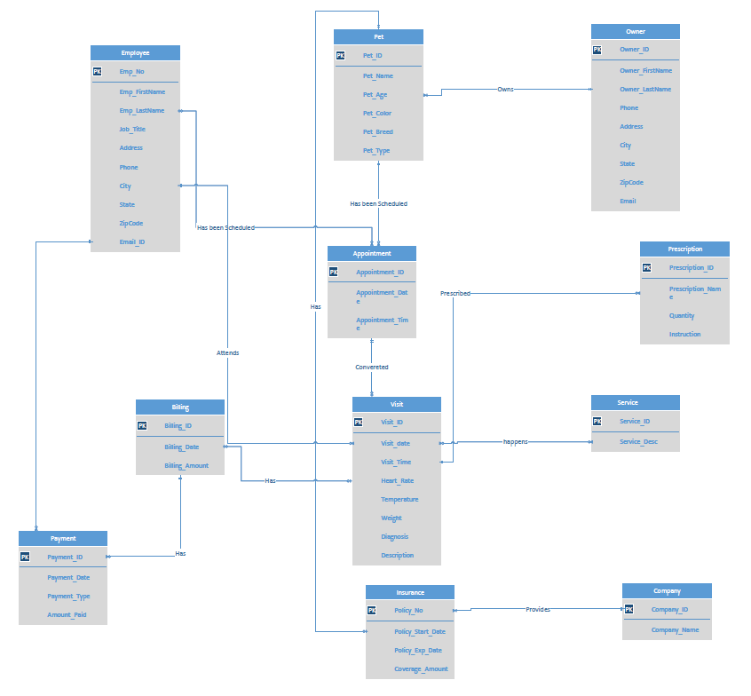

**Relational Database Schema**

Employee table:

CREATE TABLE Employee

(Emp_No INTEGER NOT NULL,

Emp_FirstName VARCHAR (50) NOT NULL,

Emp_LastName VARCHAR (50) NOT NULL,

Job_Title VARCHAR (20) NOT NULL,

Phone VARCHAR (10) NOT NULL,

Address VARCHAR (50) NOT NULL,

City VARCHAR (30) NOT NULL,

State VARCHAR (2) NOT NULL,

Zipcode INTEGER NOT NULL,

Email_ID VARCHAR (40) NOT NULL,

CONSTRAINT PKEmployeeNumber PRIMARY KEY(Emp_No));

Owner table:

CREATE TABLE Owner

(Owner_ID INTEGER NOT NULL,

Owner_FirstName VARCHAR (50) NOT NULL,

Owner_LastName VARCHAR (50) NOT NULL,

Phone VARCHAR (10) NOT NULL,

Address VARCHAR (50) NOT NULL,

City VARCHAR (30) NOT NULL,

State VARCHAR (2) NOT NULL,

Zipcode INTEGER NOT NULL,

Email VARCHAR (40) NOT NULL,

CONSTRAINT PKOwner PRIMARY KEY(Owner_ID));

Billing table:

CREATE TABLE Billing

(Billing_ID INTEGER NOT NULL,

Billing_Date DATE NOT NULL,

Billing_Amount DECIMAL (10,2) NOT NULL,

Visit_ID INTEGER NOT NULL,

CONSTRAINT PKBilling PRIMARY KEY(Billing_ID),

CONSTRAINT FKVisitID FOREIGN KEY (VisitID) REFERENCES Billing);

Payment table:

CREATE TABLE Payment

(Payment_ID INTEGER NOT NULL,

Payment_Date DATE NOT NULL,

Payment_Amount DECIMAL (10,2) NOT NULL,

Payment_Type VARCHAR (15) NOT NULL,

Billing_ID INTEGER NOT NULL

Owner_ID INTEGER NOT NULL,

CONSTRAINT PKPayment PRIMARY KEY(Payment_ID),

CONSTRAINT FK Billing FOREIGN KEY (Billing_ID) REFERENCES Payment,

CONSTRAINT FKEmployee FOREIGN KEY (Emp_No) REFERENCES Payment);

Appointment table:

CREATE TABLE Appointment

(Appointment_ID INTEGER NOT NULL,

Appointment­_Date DATE NOT NULL,

Appointment­_Time TIMESTAMP NOT NULL,

Pet_ID INTEGER NOT NULL,

Emp_No INTEGER NOT NULL,

CONSTRAINT PKAppointment PRIMARY KEY (Appointment_ID),

CONSTRAINT FKPet FOREIGN KEY (Pet_ID) REFERENCES Pet),

CONSTRAINT FKEmp FOREIGN KEY (Emp_No) REFERENCES Employee);

Visit table:

CREATE TABLE Visit

(Visit_ID INTEGER NOT NULL,

Visit_Date DATE NOT NULL,

Visit_Time TIMESTAMP NOT NULL,

Heart_Rate VARCHAR (50) NULL,

Temperature VARCHAR (50) NULL,

Weight VARCHAR (50) NULL,

Diagnosis VARCHAR (50) NOT NULL,

Description VARCHAR (50) NULL,

Appointment_ID INTEGER NOT NULL,

Employee_No INTEGER NOT NULL,

CONSTRAINT PKID PRIMARY KEY (Visit_ID),

CONSTRAINT FKApp FOREIGN KEY (Appointment_ID) REFERENCES Appointment),

CONSTRAINT FKEmployee FOREIGN KEY (Employee_No) REFERENCES Employee);

Service table:

CREATE TABLE Service

(Service_ID INTEGER NOT NULL,

Service_Desc VARCHAR (50) NOT NULL,

CONSTRAINT PKService PRIMARY KEY (Service_ID);

Insurance table:

CREATE TABLE Insurance

(Policy_No INTEGER NOT NULL,

Policy_Start_Date DATE NOT NULL,

Policy_Exp_Date DATE NOT NULL,

Coverage_Amount DECIMAL (10,2) NOT NULL,

Pet_ID INTEGER NOT NULL

Company_ID INTEGER NOT NULL,

CONSTRAINT PKPolicy PRIMARY KEY (Insurance_ID),

CONSTRAINT FKPet FOREIGN KEY (Pet_ID) REFERENCES Pet

CONSTRAINT PKInscomp PRIMARY KEY (Company_ID) REFERENCES Company);

Company table:

CREATE TABLE Insurance

(Company_ID INTEGER NOT NULL,

Company_Name VARCHAR (30) NOT NULL)

Pet table:

CREATE TABLE Pet

(Pet_ID INTEGER NOT NULL,

Pet_Name VARCHAR (20) NOT NULL,

Pet_Age VARCHAR (10) NOT NULL,

Pet_Color VARCHAR (10) NOT NULL,

Pet_Breed VARCHAR (20) NOT NULL,

Pet_Type VARCHAR (15) NOT NULL,

Owner_ID INTEGER NOT NULL,

CONSTRAINT PKPet PRIMARY KEY (Pet_ID),

CONSTRAINT FKOwner FOREIGN KEY (Owner_ID) REFERENCES Owner);

Prescription table:

CREATE TABLE Prescription

(Prescription_ID INTEGER NOT NULL,

Prescription_Name VARCHAR (30) NOT NULL,

Quantity INTEGER NOT NULL,

Instruction VARCHAR (20) NOT NULL,

Visit_ID INTEGER NOT NULL,

CONSTRAINT PKPrescription PRIMARY KEY (Prescription_ID),

CONSTRAINT FKVisit FOREIGN KEY (Visit_ID) REFERENCES Visit);

Visit_Details table:

CREATE TABLE Visit_Details

(Service_ID INTEGER NOT NULL,

Visit_ID INTEGER NOT NULL,

CONSTRAINT FKVisit FOREIGN KEY (Visit_ID) REFERENCES Visit),

CONSTRAINT FKService FOREIGN KEY (Service_ID) REFERENCES Service);

**Menu and Data Input Screens**

**Reliance Vet Clinic Main Menu**

The main menu shown below helps RVC employees to store Customer, Employees and Visit Information. The data can be edited or new records can be inserted all through this menu. This switchboard allows for easy manipulation across the database and helps keep track of appointment scheduling, transactions and prescriptions. The report tabs generate useful reports for important clerical input and pet information.

**Log IN page Form** – Allows the employees to have access to the database.

Username: admin

Password: admin

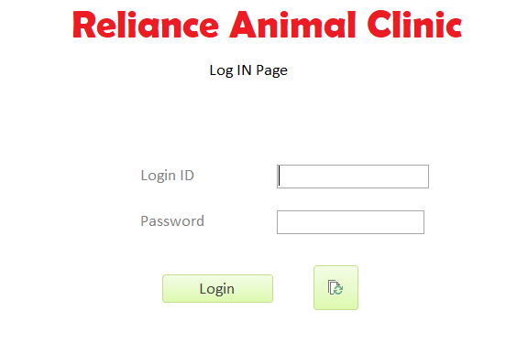

**Switchboard** – When the login credentials are accepted the application will launch into the screen which is called switchboard. It contains the buttons to various operations in the database.

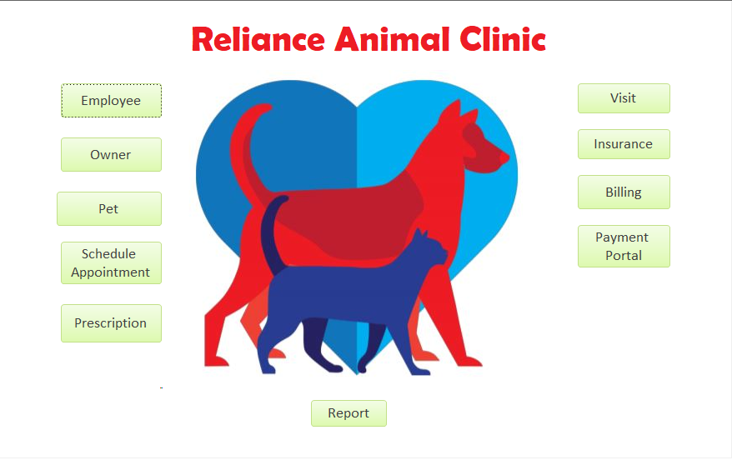

**Data Input and Manipulation Screen Forms**

**Employee Form –** This forms allows the user to input employee information listed on the employee table. The form allows for easy addition and deletion of employee. There is easy navigation to main menu by clicking on Home and to clear data by clicking “clear”.

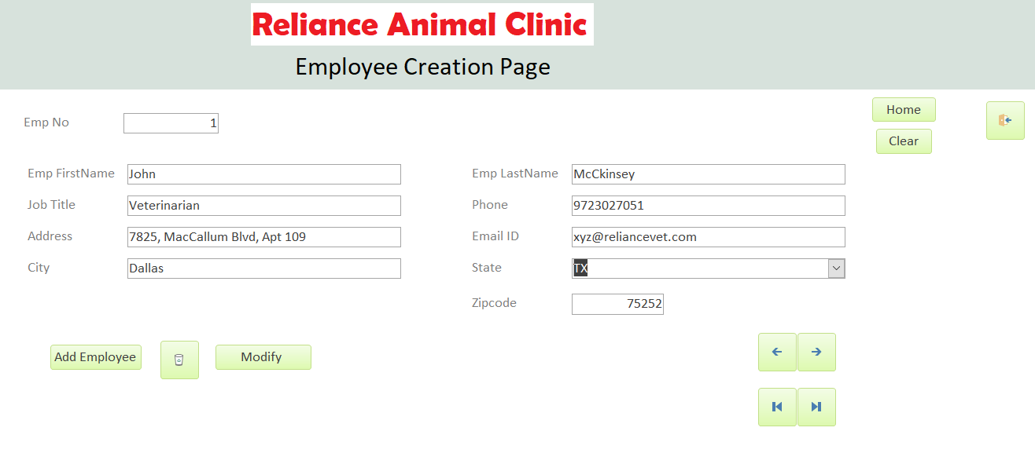

**Owner Form** – This form contains and allows to change and input the information for the owner of pets. It has buttons to add owner, update information and go back to the main menu by going home.

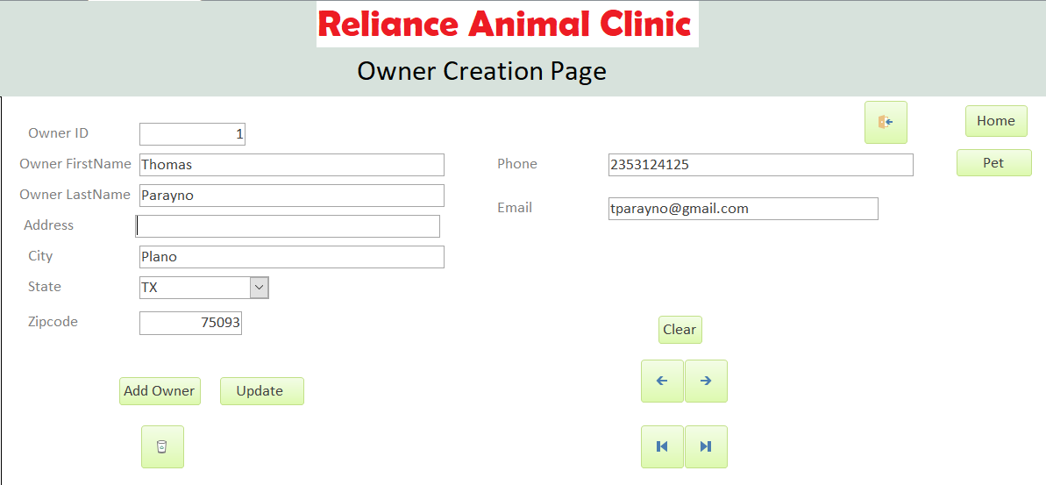

**Pet Form –** This form contains the information of the pets. Includes buttons for easy navigation and within the pet form and to be directed to appointment and main menu.

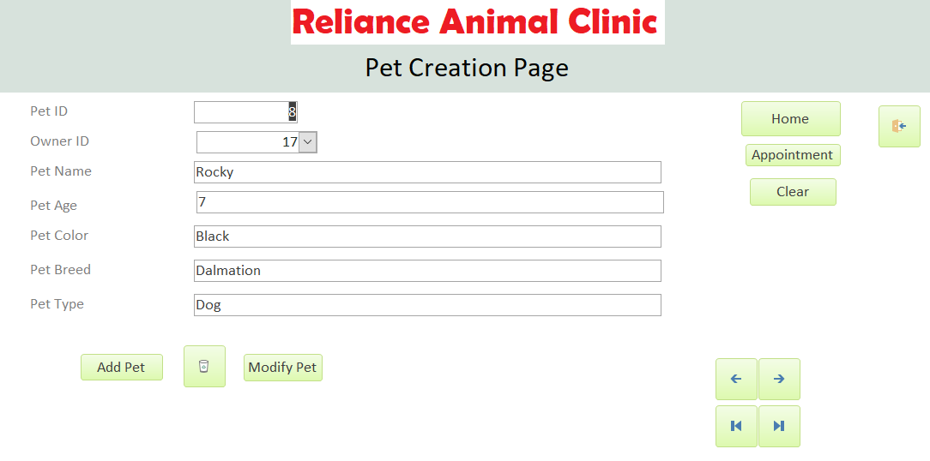

**Appointment Form** – Contains the information for the appointment tables. Allows to easily enter the information for the appointment, by clicking modify and has a delete button.

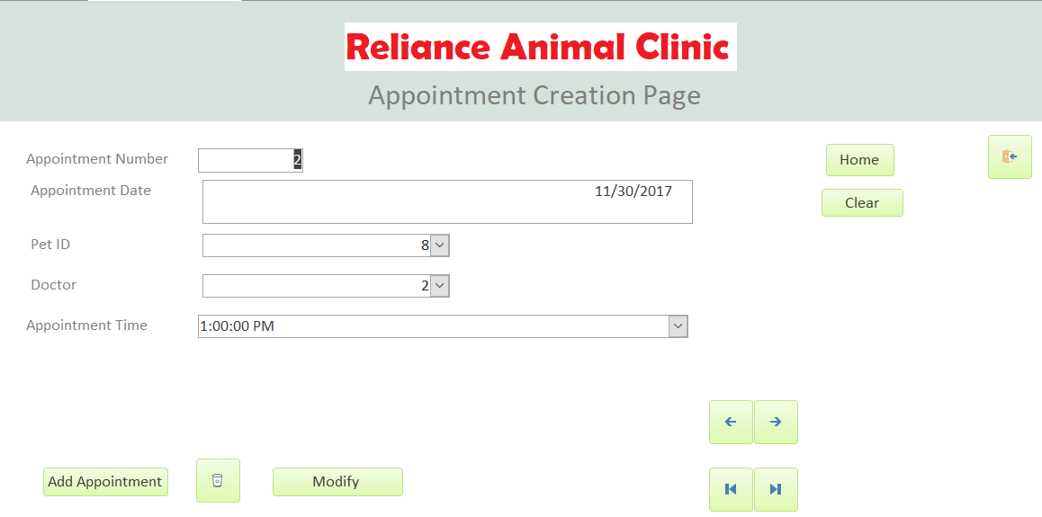

**Prescription Form** – Allows for modification of prescription information and to input new prescriptions and delete if necessary. Quick access to main menu by clicking on Home button.

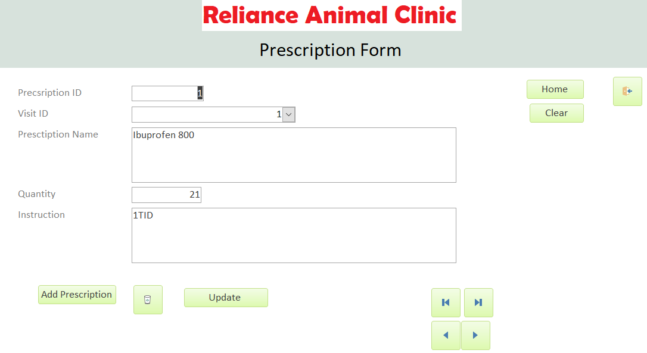

**Insurance Form** – Contains the information of insurance listed on insurance table. Easily navigate to main menu with home key. Can modify and clear information if necessary as well as add additional insurances. Has company sub form to show the company the insurance belongs to.

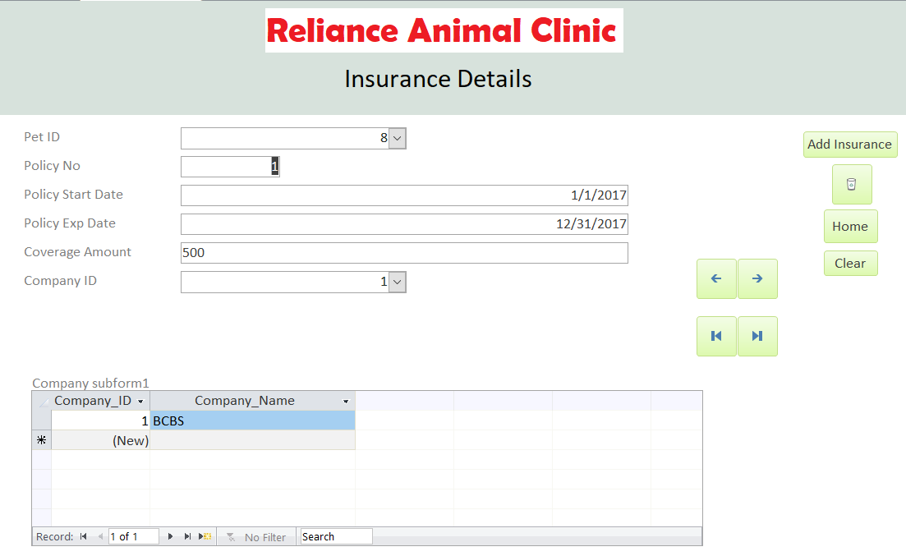

**Visit Form –** Allows for easily change and add visit information. Contains Visit Details Sub form.

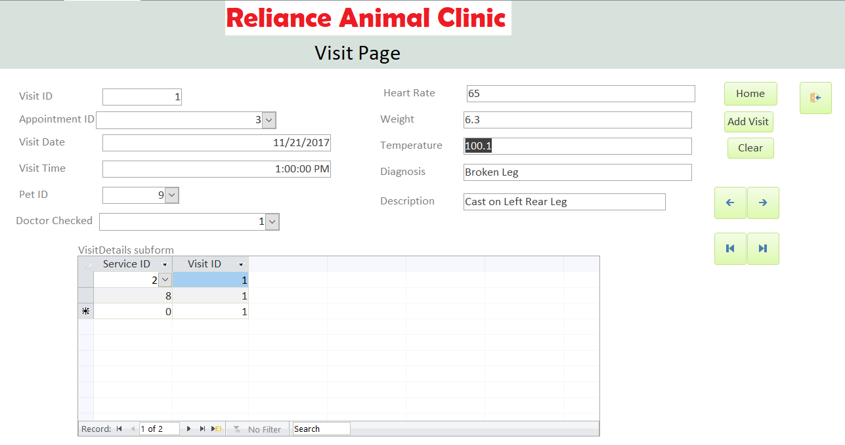

**Billing Form –** Allows the employees to modify billing, add billing or delete billing if necessary. Quick access to main menu by clicking on home button.

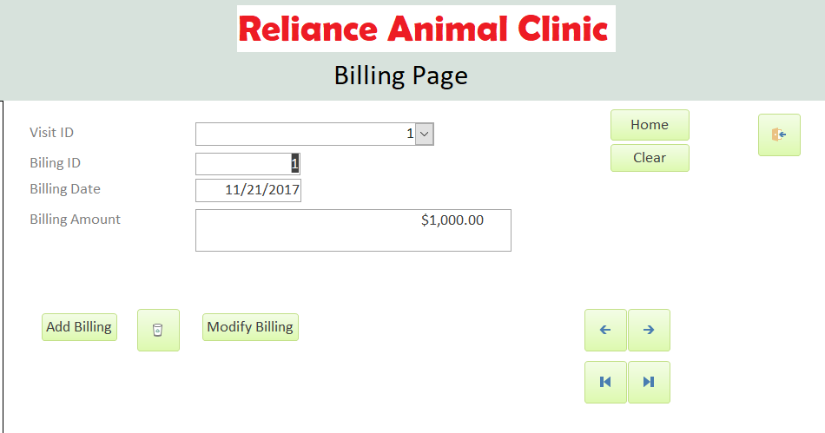

**Payment Form –** Allows the employees to enter payment information and delete in case of void transactions and allows the payment to be labeled as paid.

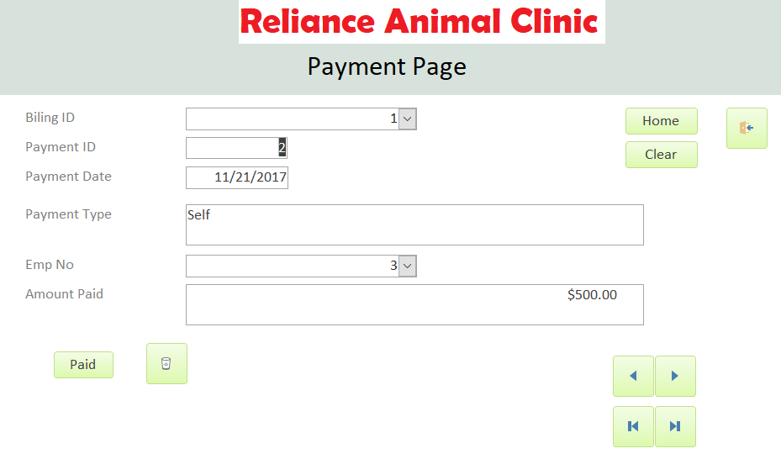

**Report Page – Interface to show the 5 sample reports obtained**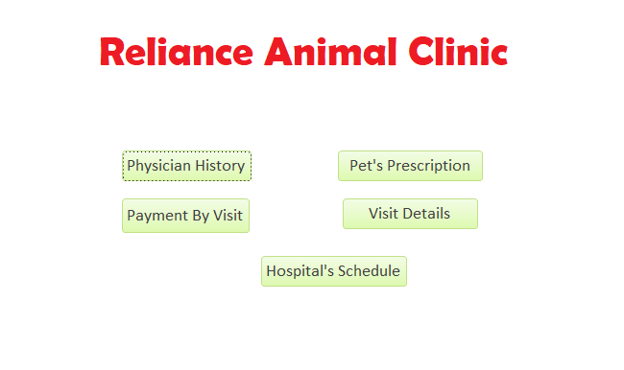

**Sample Reports**

1. **Appoinment by Veterinarian** – This report generates all the appoinment by the given veterinarian. In the sample below its all the appointments by Dr. John McCkinsey by date and the number of appoinments he had that particular date.

**Query Used**: SELECT [Employee.Emp_FirstName] & " " & [Employee.Emp_LastName] AS DocName, Appointment.Emp_No, Appointment.Appointment_Date, Count(Appointment.Emp_No) AS NoOFApptPerDay

FROM Employee INNER JOIN Appointment ON Employee.Emp_No = Appointment.Emp_No

GROUP BY Appointment.Emp_No, Appointment.Appointment_Date, Employee.Emp_FirstName, Employee.Emp_LastName;

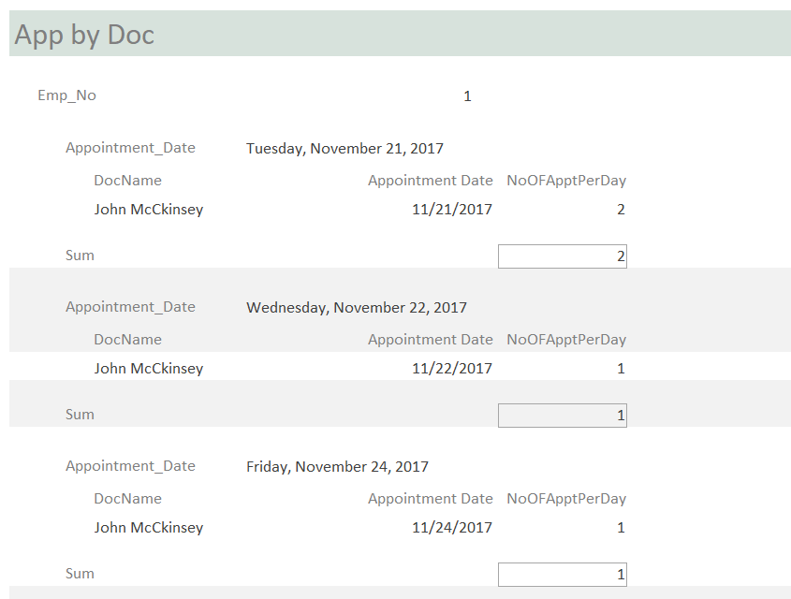

1. **Payment by customer –** Lists all the payments that have been performed by Owner. In this case Owner Kevin Nguyen and all the payments, he has done including the self-paid amount and insurance paid amount.

**Query Used:** SELECT Payment.Payment_ID, Payment.Payment_Date, Payment.Amount_Paid, Payment.Biling_ID, Payment.Emp_No, Pet.Pet_Name, Owner.Owner_FirstName, Owner.Owner_LastName, Visit.Visit_ID, Payment.Payment_Type

FROM Owner INNER JOIN (Pet INNER JOIN (Visit INNER JOIN (Billing INNER JOIN Payment ON Billing.Biling_ID = Payment.Biling_ID) ON Visit.Visit_ID = Billing.Visit_ID) ON Pet.Pet_ID = Visit.Pet_ID) ON Owner.Owner_ID = Pet.Owner_ID

GROUP BY Payment.Payment_ID, Payment.Payment_Date, Payment.Amount_Paid, Payment.Biling_ID, Payment.Emp_No, Pet.Pet_Name,Owner.Owner_FirstName, Owner.Owner_LastName, Visit.Visit_ID, Payment.Payment_Type;

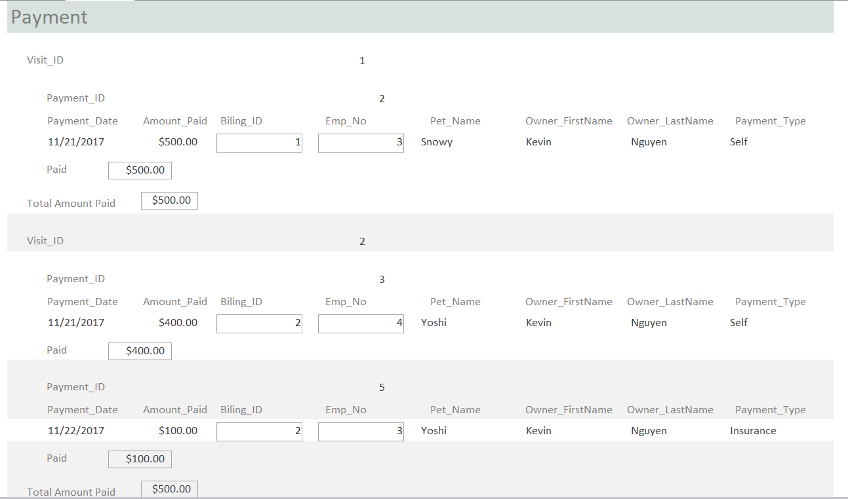

1. **Pet Information –** Lists pet information and current prescription for the pet and the visit name it was prescribed on.

**Query Used:** SELECT [Emp_FirstName] & " " & [Emp_LastName] AS Expr1, Visit.Visit_Date, Owner.[Owner_FirstName] & " " & [Owner_LastName] AS Expr2, Pet.Pet_Name, Pet.Pet_Type, Prescription.Presctiption_Name, Prescription.Quantity, Prescription.Instruction

FROM ((Owner INNER JOIN Pet ON Owner.Owner_ID = Pet.Owner_ID) INNER JOIN (Employee INNER JOIN Visit ON Employee.Emp_No = Visit.Emp_No) ON Pet.Pet_ID = Visit.Pet_ID) INNER JOIN Prescription ON Visit.Visit_ID = Prescription.Visit_ID;

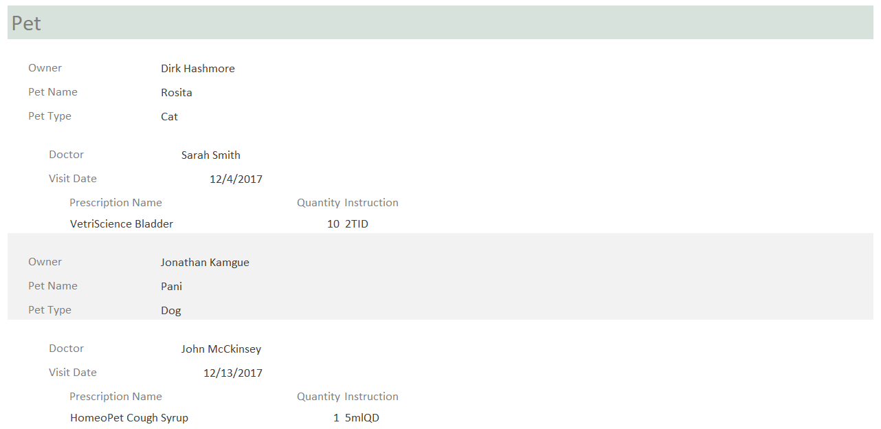

1. **Visit Details –** Provides the details for the visit of each pet including the information of Veterinarian that performed diagnosis and the service that was done.

**Query Used:** SELECT T1.Visit_ID, T1.Visit_Date, T1.Heart_Rate, T1.Temperature, T1.Weight, T1.Diagnosis, T1.Service.Service_Desc, T1.Pet_Name, T1.Pet_Type, T1.Owner_FirstName, T1.Owner_LastName, T1.Emp_FirstName, T1.Emp_LastName

FROM (SELECT Visit.Visit_ID, Visit.Visit_Date, Visit.Pet_ID, Visit.Heart_Rate, Visit.Temperature, Visit.Weight, Visit.Diagnosis, Service.Service_Desc, Visit.Emp_No, Pet.Pet_Name, Pet.Pet_Type, Pet.Owner_ID, Owner.Owner_FirstName, Owner.Owner_LastName, Employee.Emp_FirstName, Employee.Emp_LastName FROM Employee INNER JOIN (Owner INNER JOIN (Pet INNER JOIN (Service INNER JOIN (Visit INNER JOIN VisitDetails ON Visit.Visit_ID = VisitDetails.Visit_ID) ON Service.Service_ID = VisitDetails.Service_ID) ON Pet.Pet_ID = Visit.Pet_ID) ON Owner.Owner_ID = Pet.Owner_ID) ON Employee.Emp_No = Visit.Emp_No) AS T1;

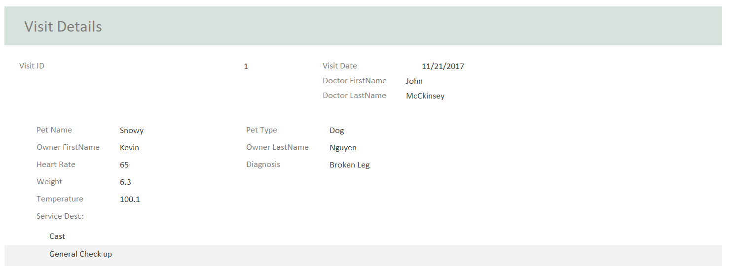

1. **Weekly Schedule –** Lists all the appointment for a given week, including pet name and owner information. In the sample below is for week 47.

**Query Used:** SELECT Appointment.Appointment_Date, Appointment.Appointment_Time, Pet.Pet_Name, Owner.[Owner_FirstName] & " " & [Owner_LastName] AS Owner_Name, Owner.Phone

FROM (Owner INNER JOIN Pet ON Owner.Owner_ID = Pet.Owner_ID) INNER JOIN Appointment ON Pet.Pet_ID = Appointment.Pet_ID;

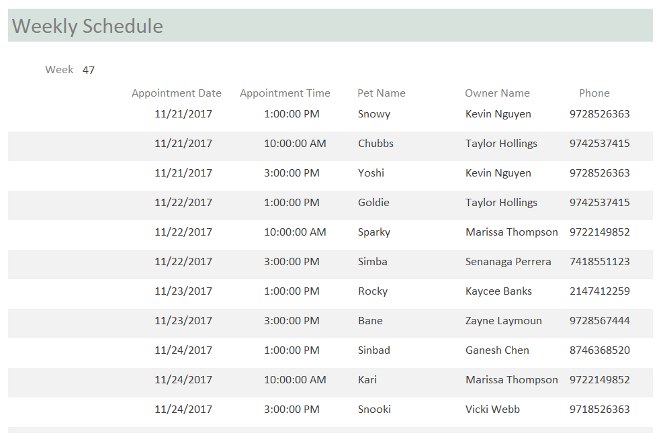

**Contributions**

* **Yenglui Chia** 
  + **Wrote First Draft of Report**
  + **Worked on Data Entry**
  + **Worked on Design of Forms**
  + **Wrote and Formatted Final Report**
* **Rushi Dalal**
  + **Worked on ER diagram**
  + **Worked on Relational Database Schema**
  + **Worked on Design of Forms**
  + **Worked on Problem Description and proofreading Final Report**
  + **Worked on Inserting Synthetic Data**
* **Priyank Patel**
  + **Worked on inserting synthetic data**
  + **Worked on relational database schema**
  + **Worked on sample reports**
  + **Worked on data input screen report forms**
* **Raghavan Krishnan Veera**
  + **Worked on designing the tables and the attributes**
  + **Worked on ER diagram**
  + **Worked on table creation**
  + **Worked on designing the forms**
  + **Worked on writing queries in populating the required information**
  + **Worked on writing queries for the creating reports**
  + **Worked on designing the reports**